Numerical Simulation of Microwave Induced Stress in Rocks

# Table of Content

# Introduction

Mechanical method of tunneling requires large amount of energy.

Thorough tremendous development in comminution, the lives of the cutter blades have been greatly extended. However, the excessive high wear of the blade in abrasive or hard rock still presents huge challenge to this method of rock breaking.

Microwave offers great improvements to the process as a method of preprocessing the rock. The preprocessing heating and cooling of the rock greatly reduce the strength required for the boring process.

The process of heating and cooling rapidly introduce great amount of thermal stress in the body. Depending on the Electromagnetic, thermal and mechanical property of the body, enough energy delivered in a short timeframe can exceed the ultimate tensile strength of the rock and cause the inter crystal fracture and intra crystal fractures to form. These fractures reduce the structure integrity of the rock and allow boring blades to deliver their energy more efficiently.

# Literature Review

# Methodology

The entire simulation is built in a step by step manner to give a holistic view of the process.

## Simple Geometric Construction

Several different simple geometric shapes are designed and investigated using MEEP. The configurations include different particle sizes, shapes and different distant between the particles.

In the further investigation, the non-linearity of the dielectric property of the material should be investigated as well.

## Geometric construction

The simple geometries gives us an understanding of the nature of EM wave propagation as an intensity profile can be generated from the resulting EM wave profile.

Complex geometry that are more closely resemble the real-life situation

The geometry is generated using Python **Voronoi** Algorithm.

**Voronoi** algorithm generate randomized geometry based on the randomly generated seeds and the distance of each section of geometry is from the seeds.

The geometry is then transferred to Abaqus using **Convex Hull** algorithm.

In the figure shown. The solid parts are the microwave-absorbing particles and the transparent parts are the microwave-transparent matrix.

Ratio of the particles and density of the particles is customized.

The mechanical property of the micro-structure is also randomized using Weibull distribution.

## Electromagnetic simulation

EM field is generated and propagated in the software MEEP.

The MEEP is an open source Finite Difference Time Domain (FDTD) software.

We constructed different geometry and materials for EM wave propagation test. A procedure is store the randomly generated geometry in a database and read it in MEEP for simulation.

Different frequency of EM wave is also specified to test.

The result of MEEP simulation is analyzed in MATLAB to assert the correctness.

A Root Mean Square (RMS) value matrix is generated to discover the absorption of different parts of the model.

## Thermal simulation

## Structure simulation

## Fracture simulation

# Future improvements

## Methodology improvements

## Simulation chain extension

# Results

## Simple geometry results (3D modelling)

## Shape

### Square

### Circle

### Triangle

## Size

### Relative to wavelength

### Critical size formula

## Spacing or channel for light

### Relative to wavelength

## Filling factor

## Anisotropic inhomogeneous dielectric constant

## 2D vs 3D results comparison

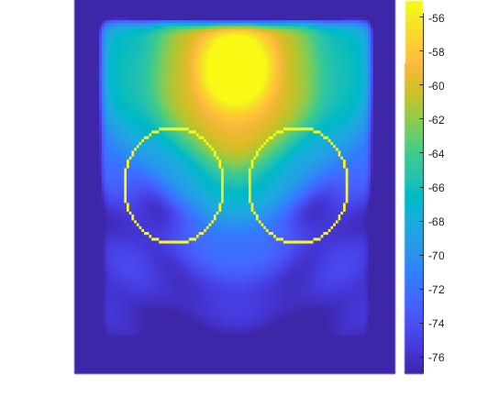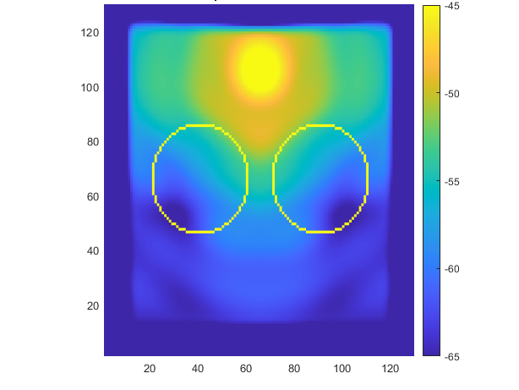

3D vs 2D simulation

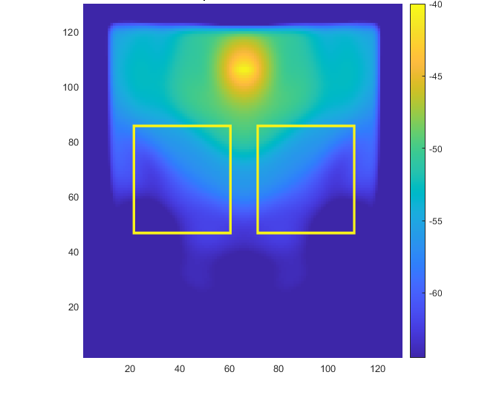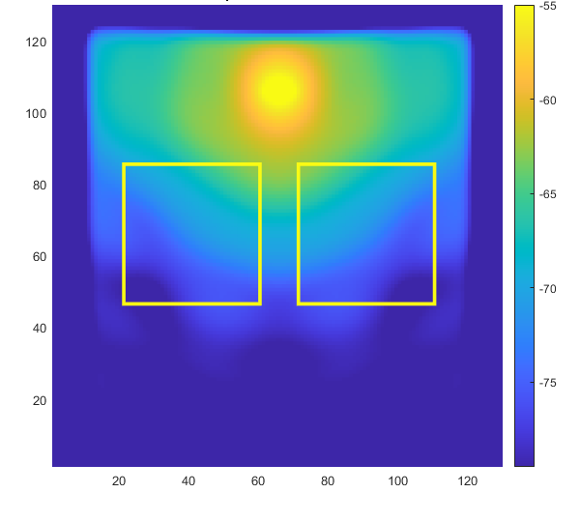

3D vs 2D simulation

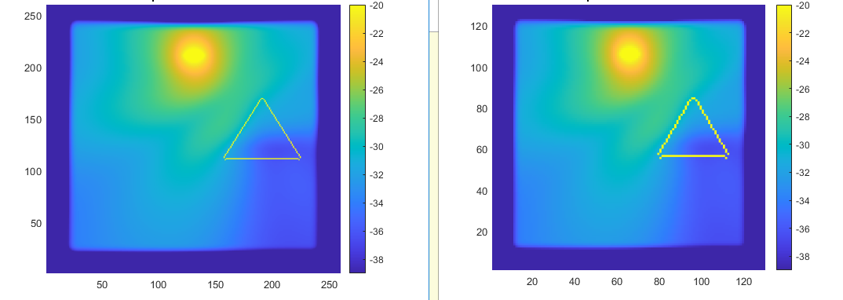

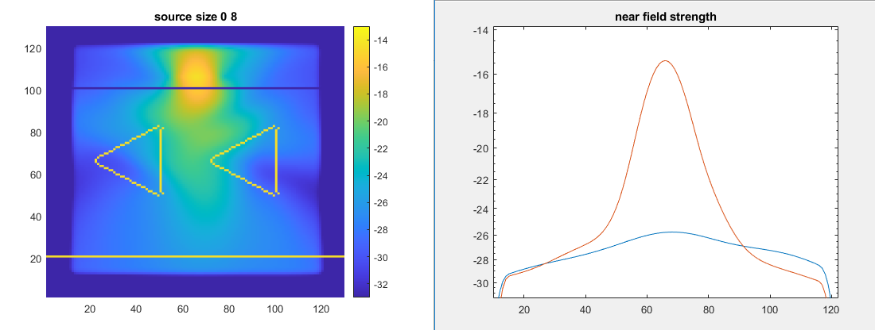

Different resolution

Distribution of the particles greatly affects penetration and power distribution of the EM field. Knowing the composition of the rock beforehand can aid the application of Microwave and subsequent drilling action.

The results show that the less dense particle, the greater the penetration. This can be shown in the graph below. As the distance of the particles get closer, the microwave field that penetrate the rock decrease in strength. This can direct the usage of Microwave in the situation that the particle composition of the rock is known. If the particle is denser, hence the rock more inhomogeneous, the higher strength microwave is required.

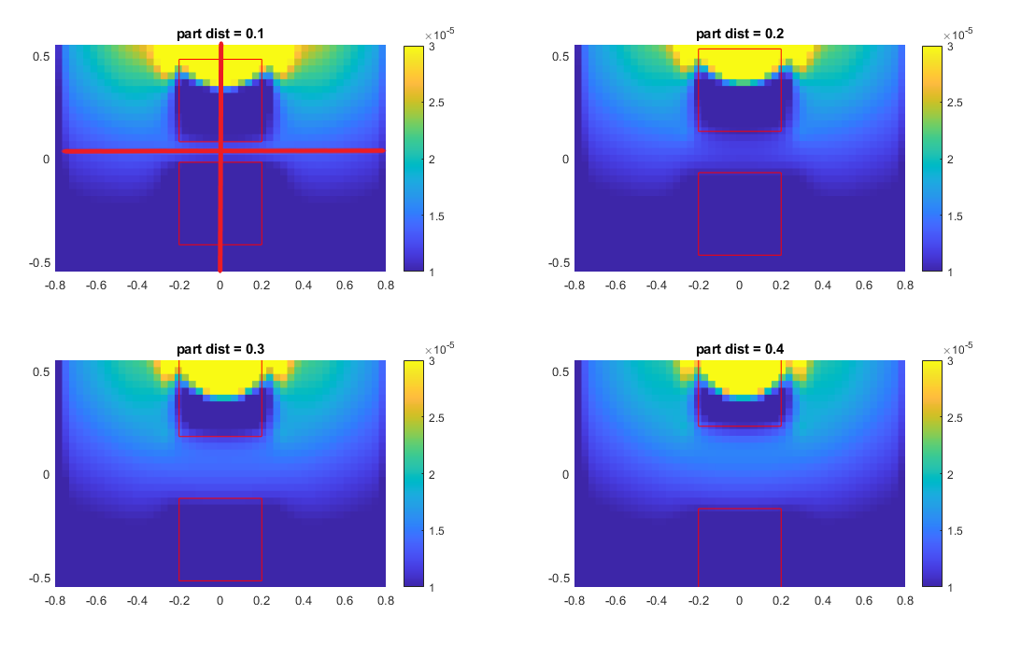

Figure 1. RMS energy profile of Different particle distance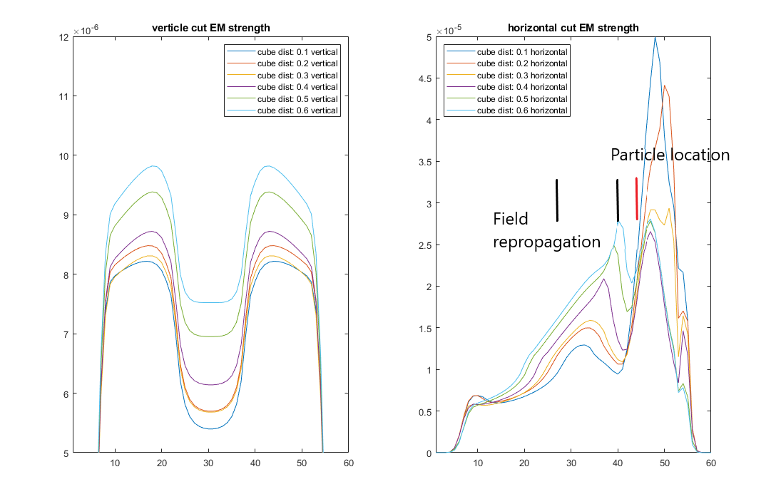

Figure 2. Cross section intensity

The cross-section intensity profile shown above demonstrate how the strength of EM field varies with the particle distribution. The strength of vertical strip of EM field increases and the distance between the particles increases. From the horizontal cut of the strength profile, we can see that the particles result in a drastic decrease the EM field strength. However, after the particle, the EM field is refilled due to the dispersion.

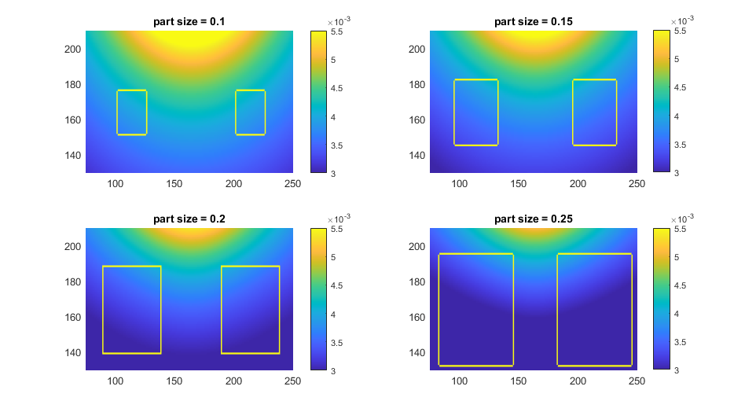

The size of the particle plays an important role in shaping the propagation of the EM field. As the size of the particle increase, the strength of the EM wave decreases globally. Strength and scale are reduced.

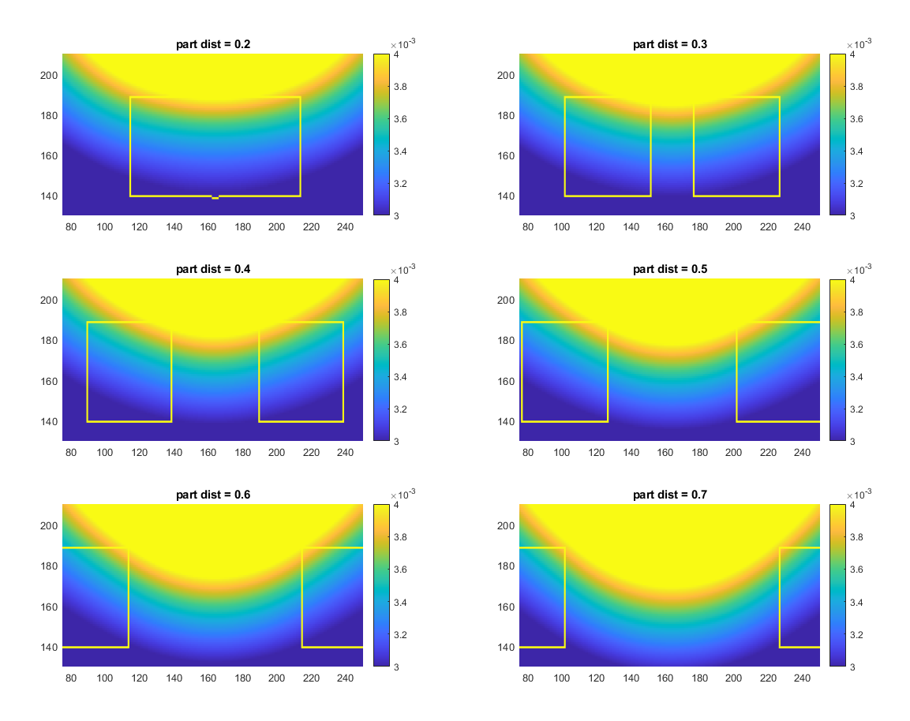

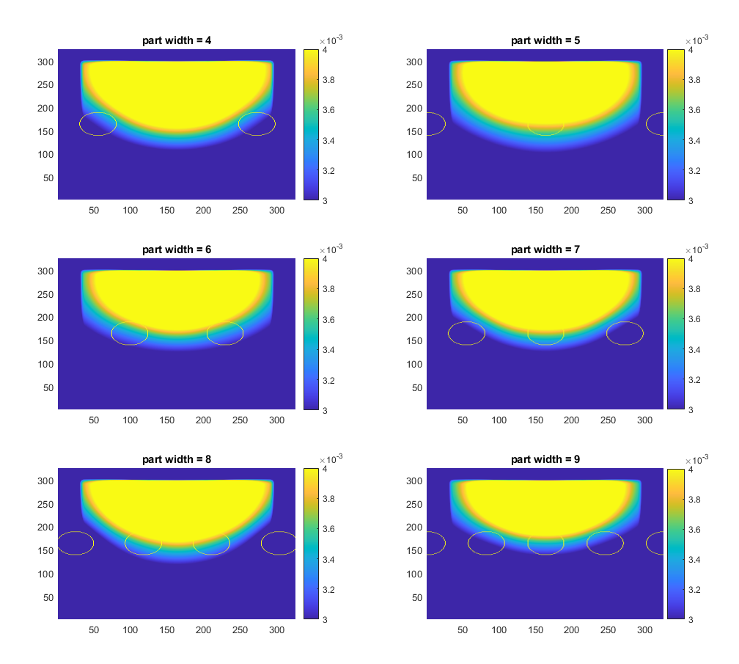

The EM wave does not propagate well through slits. The depth reached by the EM field is proportional to the width of the slit. The wider the slit, the deeper the EM field penetrates. The reason is that the wavelength of the Microwave is close in proportional to the size of the slit, thus making it hard to penetrate.

Detail different wavelength and slit width. Rock particle size and interaction with the wavelength of the microwave.

In practice, different wavelength of the EM wave should be used for different composition of rocks.

**Far field radiation**

**Color scale problem**

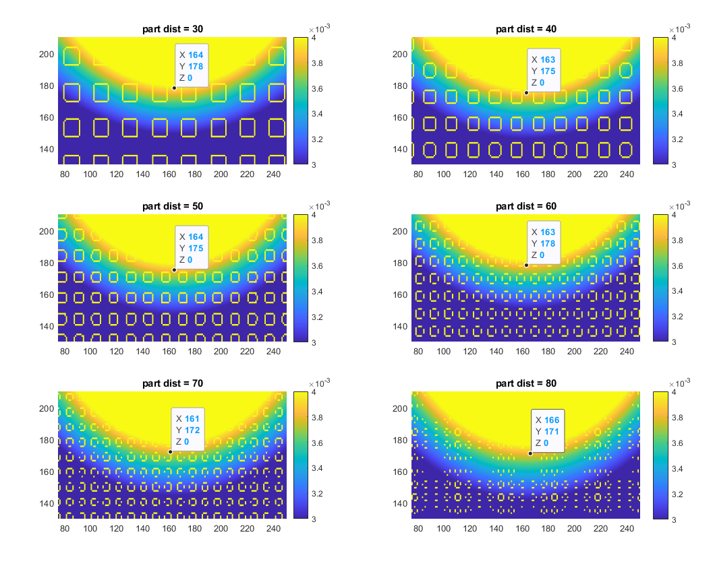

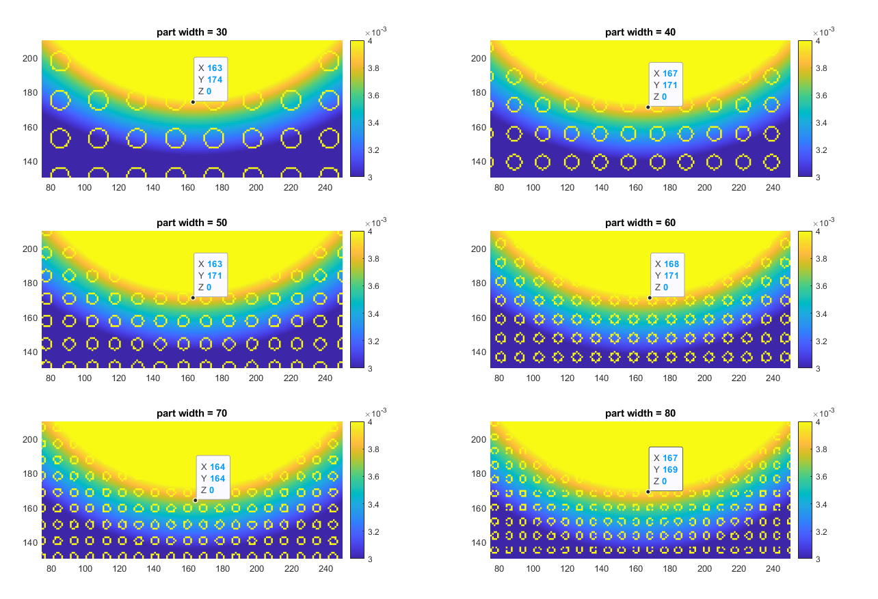

In the subsequent 2 investigation, we used two different shape, square and circle to perform 2D simulation. The results show that even though the size of the particle is different, due the same filling factor (50%), the propagation of the EM wave reach the same depth. Combine this with the result from the above shows that the filling factor plays the more important role in the penetration depth of the EM wave than the size of the particles.

Critical size of the particle size in relation to the wavelength.

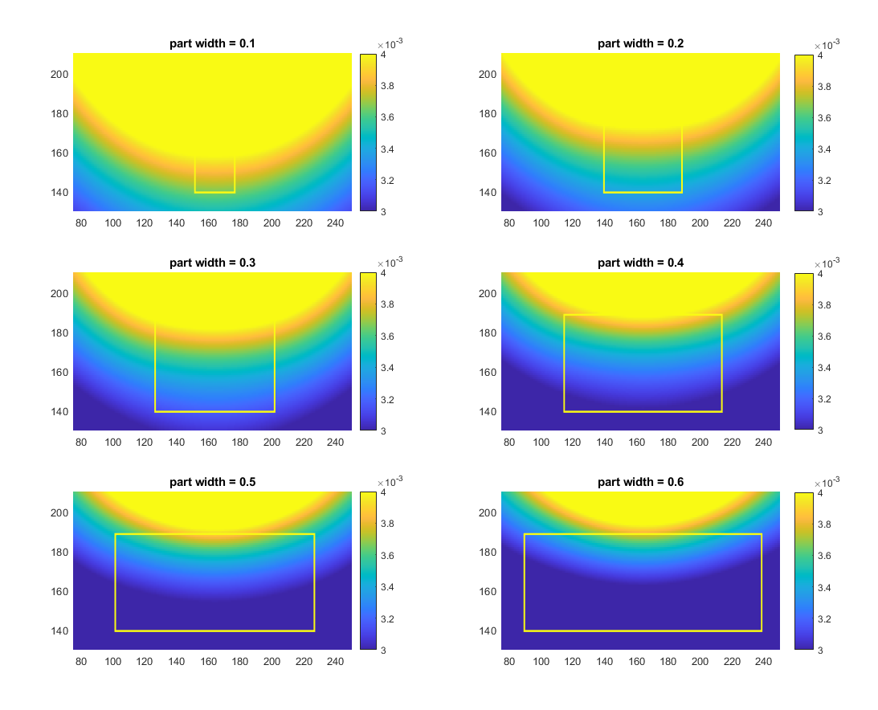

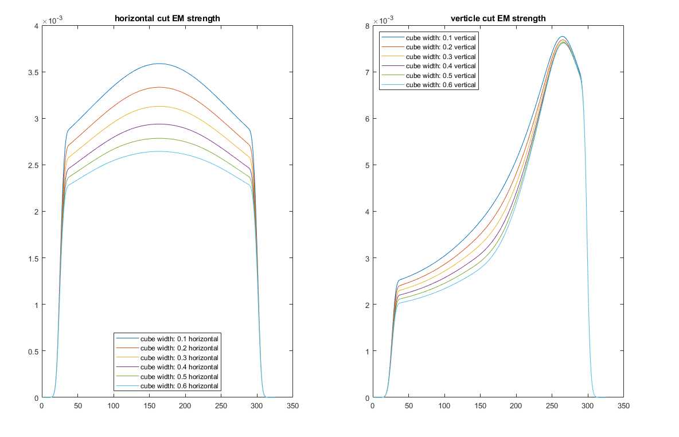

In the investigation above, rectangular particle with different width is place in the center. We can observe that when the width of the rectangle increases, the propagation of the wave is limited by the particle.

Again, a slice of horizontal cut and vertical cut is taken from each width, which resulted in the plot. From the horizontal cut, we can see that the strength of the EM field decreases with the increase in width of the particle. From the vertical cut, we can see that the steepest decrease in strength take place just before the interface between the particle and the medium.

This indicates that the microwave penetrates uniform particles less well. Higher strength field needs to be applied when the rock is made up of more uniform particles.

*Quote MEEP documentation: In particular, because Maxwell's equations are scale invariant (multiplying the sizes of everything by 10 just divides the corresponding solution frequencies by 10)*

*The frequency of EM wave has a dramatic effect on the efficiency of the wave penetration and heating in the rocks.*

Surface roughness (combine multiple small particles), size, distance, shape.

**Finding:**

**and benefit:**

The results show that the lower the wavelength, the deeper the penetration.

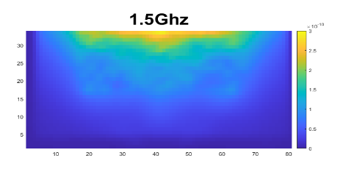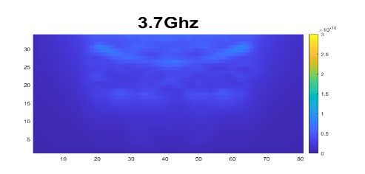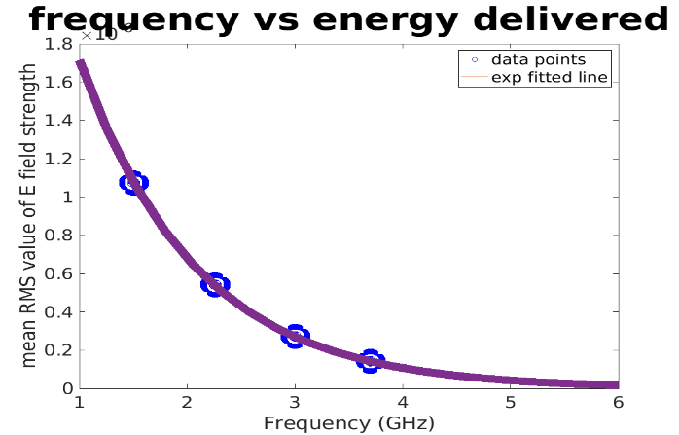

Figure 3. RMS energy profile of E field (left) and fitted line of frequency vs Energy delivered

The thermal and stress are coupled in simulation in Abaqus.

The results show that the temperature gradient is the major cause of stress.

# Conclusion

In this paper, a novel approach to preprocessing the rock using microwave before the mechanical comminution is presented.